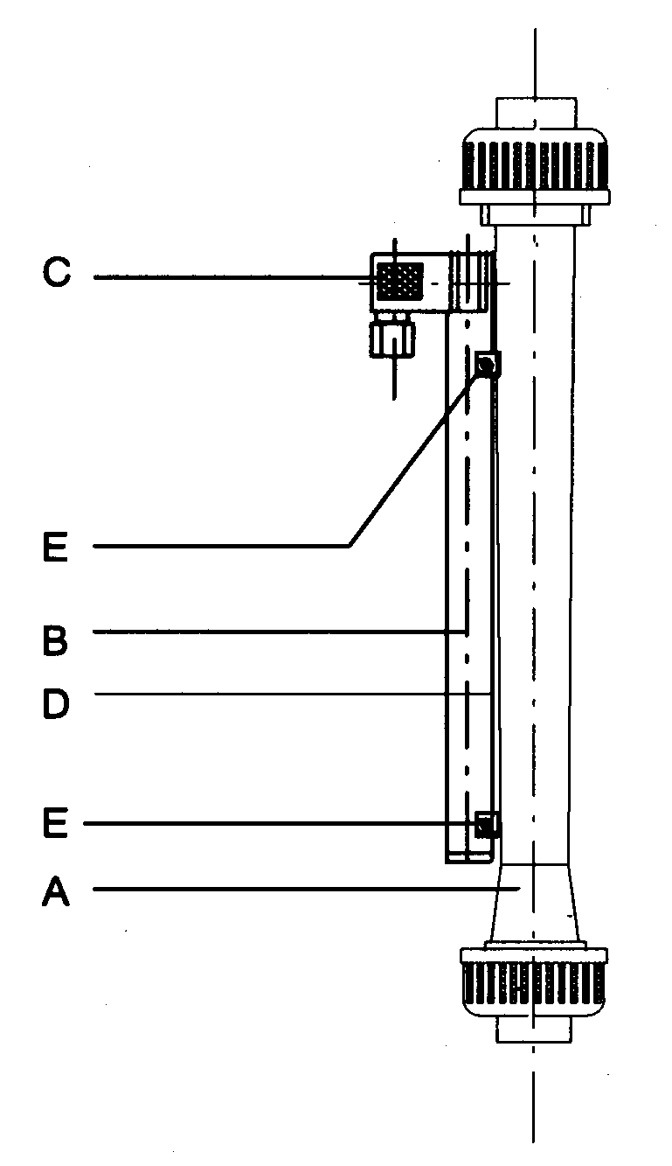
Function
Measuring-sensor Z50
for flow-meter M23

Functional parts:
A) flow-meter M23 with monostable magnetic float
B) measuring-Sensor Z50
C) connection
D) dovetail to mount Z50
E) clamping screw to hold the measuring sensor in position

Advantages:
● simple assembling
● analoge outgoing signal 4 – 20 mA
● 24 V DC power supply
● protected by IP 65
● body of PVC-U
● connection through DIN plug

The measuring-sensor Z50, which is mounted on the flow-meter M23, supplies in proportional to the position of the magnetic float an analog outgoing signal of 4-20mA. This signal can be used directly without any additional plotting station. This means a really competitive possibility for the remotely -indication or -regulation of the flow rates. Of course Z50 can be assembled later into the application. Required is just a monostable magnetic float in the flow-meter. For the best possible reproducibility we offer two different measuring sensors Z50, which are optimal adapted for the different measuring ranges.

Assembling-guide
- put the measuring-sensor on the dovetail of the flow-meter
- adjust the marking on the measuring-sensor with the 50% marking of the scale on the flow-meter
- tight the clamping screw
- put off and wire the plug acc. to default

Technical datas
measuring-sensor type measuring range l/h
line-voltage | 24 V ± 10 %
current consumption | ca. 6 mA 4 mA at the power interface
apparent power resistor | min. 0 Ohm, max. 250 Ohm
current-exit | 4-20 mA max. voltage increase + 5 V
electr. tolerance | max. + 1-3% from measuring value
protection | IP 65 acc. DIN 40050
allowed ambient temperature | 0 °C – + 50°C
connection | DIN plug DIN 43650
protection device | reverse battery protection / intigrated noisefilter for the operating voltage

15 -150
Z50/1 100-1000
Part-no: ON REQUEST 1200-12000
2000-20000
3000-30000

Z50/2 50-500
Part-no: ON REQUEST 200-2000
300-3000

Electrical connection:

Pin 1 : operating voltage 24 V 1 Ø + 24 V
Pin 2 : outgoing signal 4-20 mA 2 Ø 4 – 20 mA-------R
Pin 3 : 0 V 3 Ø

